CN Project

[Computer Networks (SRM Institute of](https://www.studocu.com/in/course/srm-institute-of-science-and-technology/computer-networks/4986586?utm_campaign=shared-document&utm_source=studocu-document&utm_medium=social_sharing&utm_content=cn-project414418419) [Science and Technology)](https://www.studocu.com/in/course/srm-institute-of-science-and-technology/computer-networks/4986586?utm_campaign=shared-document&utm_source=studocu-document&utm_medium=social_sharing&utm_content=cn-project414418419)

**PROJECT TITLE:** Wi-Fi based home automation system

A COURSE PROJECT REPORT BY

T. Bhavana

Ganesh Chappi

Bheema Shyam Kumar

Sai Harshith Yaddala

**ACKNOWLEDGEMENT:**

We express our heartfelt thanks to our honorable **Vice Chancellor Dr. C. MUTHAMIZHCHELVAN**, for being the beacon in all our endeavors.

We would like to express my warmth of gratitude to our

**Registrar Dr. S. Ponnusamy,** for his encouragement

We express our profound gratitude to our **Dean (College of Engineering and Technology) Dr. T. V.Gopal,** for bringing out novelty in all executions.

We would like to express my heartfelt thanks to Chairperson, School of Computing **Dr. Revathi Venkataraman,** for imparting confidence to complete my course project

We wish to express my sincere thanks to **Course Audit Professor Dr.M.LAKSHMI, Professor and Head, Data Science and Business Systems** and **Course Coordinator Dr.E. Sasikala, Associate Professor, Data Science and Business Systems** for their constant encouragement and support.

We are highly thankful to our my Course project Internal guide **Subject handling staff name , Designation , Department,** for **his/her** assistance, timely suggestion and guidance throughout the duration of this course project.

We extend my gratitude to **Student HOD name Department**

and my Departmental colleagues for their Support.

Finally, we thank our parents and friends near and dear ones who directly and indirectly contributed to the successful completion of our project. Above all, I thank the almighty for showering his blessings on me to complete my Course project

**TABLE OF CONTENTS**

**CHAPTERS CONTENTS PAGE NO.**

1. **ABSTRACT**
2. **INTRODUCTION**
3. **REQUIREMENT ANALYSIS**
4. **ARCHITECTURE & DESIGN**
5. **IMPLEMENTATION**
6. **EXPERIMENT RESULTS & ANALYSIS**
   1. RESULTS
   2. RESULT ANALYSIS
   3. CONCLUSION & FUTURE WORK
7. **REFERENC**

## ABSTRACT

Secure Wi-Fi technology is used by server, and hardware interface module to communicate with each other. User may use the same technology to log in to the server web-based application. If server is connected to the internet, so remote users can access server web-based application through the internet using a compatible web browser. For example, The home automation system can control the following appliances:

* 1. Lights on/off/dim
  2. HVAC on/off
  3. Door lock
  4. Window shutdown
  5. On/off different appliance and etc.

## Introduction:

In today’s technologically growing world technological development without becoming a requirement that is frequently used in today’s human life. Living home that includes smart objects with specific functions is called smart home. i.e aimed to improve safety, comfort and efficiency. Which can be used to automate home activities without users using various sensors (Temperature, Humidity, Smoke, Wind, Sound) to monitor the home environment. And there are usually monitoring tools, and the devices that are controllable and automatic this can be accessed via an internet-connected computer or smart mobile device. Instead of providing security that is safe, smart home can provide different features to provide automatic security using various alarm systems, as LCD display and siren sound and by sending email to valid users if sensor detects security issues. Home automation states handling and monitoring home items using microcontroller or computer technology. Automation is common because it makes the process simple, productive and secure. All smart

devices are registered at the home gateway in this paper and operated by a legitimate person. By including different sensors in home automation, Smart Home eliminates user engagement in tracking home settings and operating home appliances. IOT (Internet of Things) is a system in which people, objects with a specific identity and moving capacity information without needing a dual human-to- human origin, i.e destination or contact between people and computers IoT and IoE are a well versed technology which optimizes the life based on smart sensors and smart devices which operate together on the internet. All (IoE) web is a theory that extends machine-tomachine communication (M2M) emphasis of the Internet of Things (IoT) to describe a more complex system that also includes people and processes. IoE is a smart people, method, information and stuff relation. The Internet of All (IoE) describes a system in which billions of entities have sensors for measuring and determining their status; all linked by common or proprietary protocols over public or private networks. This paper describes the implementation of smart home with the use of latest version of cisco packet tracer as this version includes different sensors, actuators and smart devices used for home automation. Chic lights, chic windows, chic fans, chic doors with different detectors and sensors are some of the devices. Latest version the simulation program for cisco packet tracer odeling and configuration of IOE systems with conventional networking system to implement smart home.

# REQUIREMENT ANALYSIS

* **REQUIREMENT SPECIFICATION** :- Server

Router WRT-300N Switch

Laptop

IOT Smart Fan, windowAir Conditioner Siren

Web Cam Motion Sensor Smoke Detector

Humiture Monitor Lawn Sprinkler

**Software Requirements:-**

Operating System: Windows

Platform: Cisco Packet

Tracer

Back end: IOT Server Languages: HTML

Programming Language : JavaScript

# ARCHITECTURE AND DESIGN:

The below figure shows the overall design of our system. There is a server setup which is connected to a switch and router. The IoT devices are connected to the server and can be accessed from anywhere within range. The devices can be accessed using a laptop or mobile which is also connected to the network.

The design shows how different devices can be connected inside a smart home through the internet of things. The different devices used for designare as follows -

1. IoT and Radius server - Remote Authentication Dial-In User Service is a networking protocol that provides centralized authentication, authorization, and accounting management for users who connect and use a network service. This server is to monitor intelligent things that are recorded on it and to have specific database features .
2. Router(WRT300N) - Used to link different devices to the network of cellular.
3. Laptop - Link to your home destination to access intelligent objects.
4. Smartphone - To access the IoT devices from anywhere.
5. Fan - Used for ventilating the home environment on the basis of certain circumstances.
6. Webcam - For security to see who is coming in the house it gets activated only when the motion detector detects any movement and the webcam takes pictures and sends it to the server.
7. Siren - Provide sound at home for some cases for example if fire breaks out.
8. Motion detector - Link to your home getaway and detect motion.
9. Smart door - Link to your home getaway and detect motion to open or close automatically.
10. Lawn sprinkler - Used as a sprinkler based on environmentalwater level.
11. Smoke sensor - Used to sense the smoke level.
12. Older car - Used to model various home development scenarios as it affects the amount of oil, co2 and smoke. At a level of 1 percent an hour, this absorbs carbon monoxide. At a level of 2 percent an hour, this absorbs carbon dioxide. Affects Smoke at an hourly rate of 3%.
13. AC - Used at a level of -2 percent an hour to cool the home affects humidity.
14. Smart window - Used to remotely control the window impacts Argon, Carbon Monoxide, Carbon Dioxide, Hydrogen, Helium, Methane, Nitrogen, O2, Propane, and Smoke.
15. Smart Light - Used to give light for home.
16. Humiture Meter - Displays current humiture, which is (temperature+humidity)/2 to the closest integer.

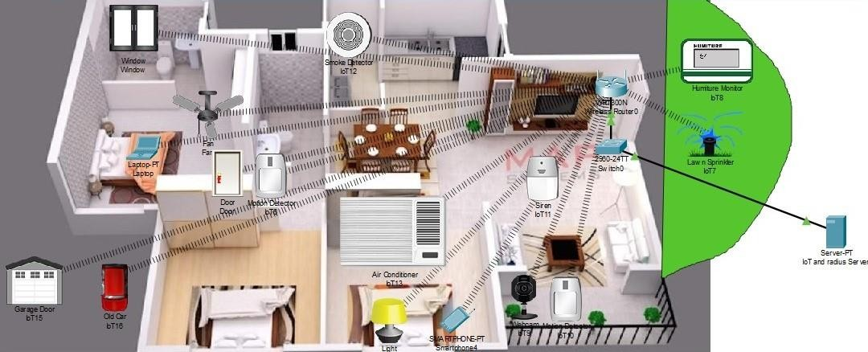

### IMPLEMENTATION

Including various smart objects which are used for implementing home automation such as windows, fans, lights, doors, lawn sprinklers, webcams and various sensors. The router and server are used for controlling the objects and sensors, which provide a programming environment for controlling objects that are connected and provide control mechanisms through the registration of Home Gateway smart devices.

#### ROUTER(WRT300N)

The router is set up with an IP address and default gateway. Then we change the network SSID name to “Home”. In the wireless security section the network mode is selected to WPA2 Enterprise. Then the encryption is selected which we set to AES here. We set the radius server option here to what we registered our server with. Here we also provide the shared password for the router. The figure below show the different configurations ofthe router.

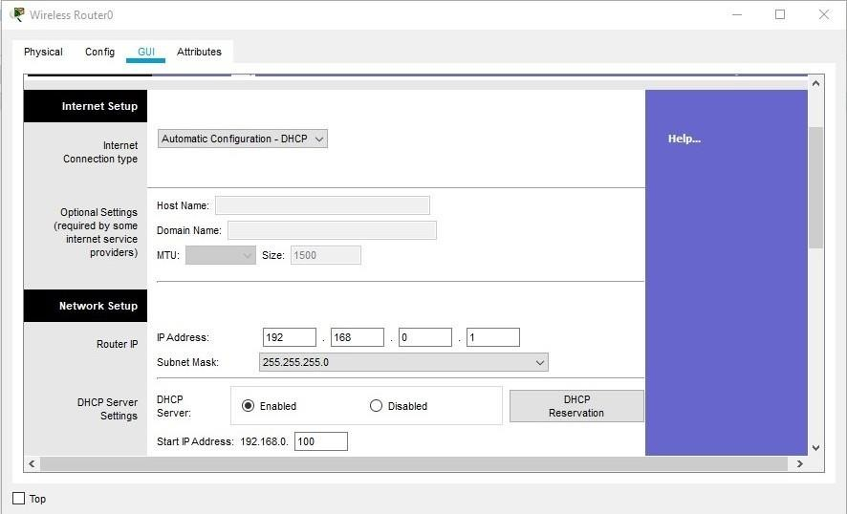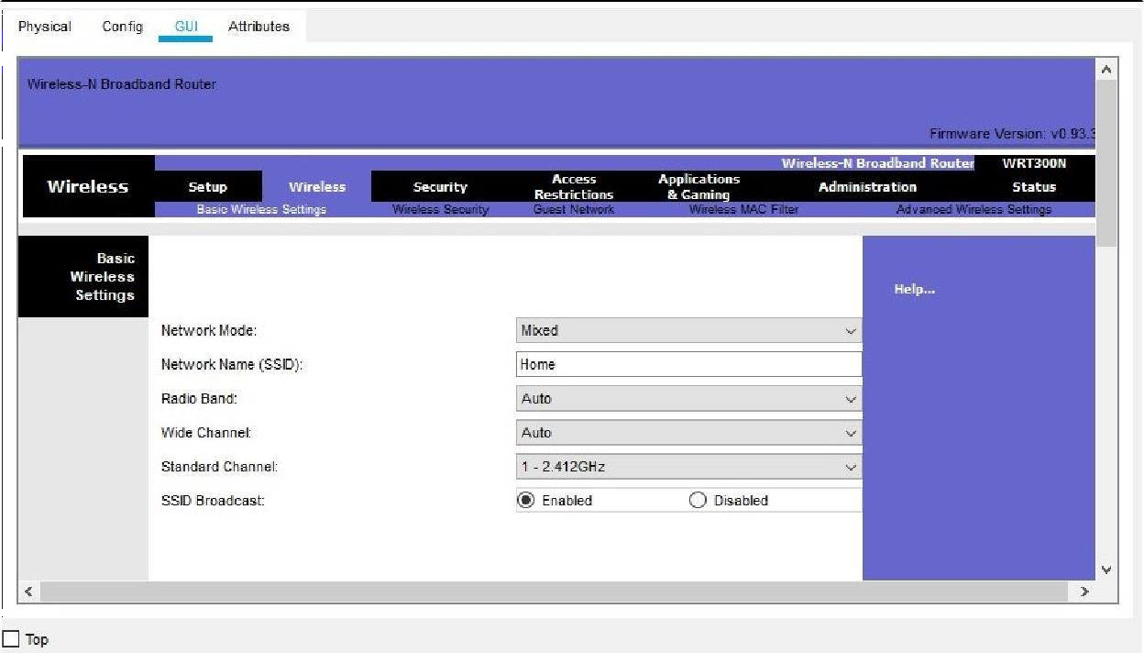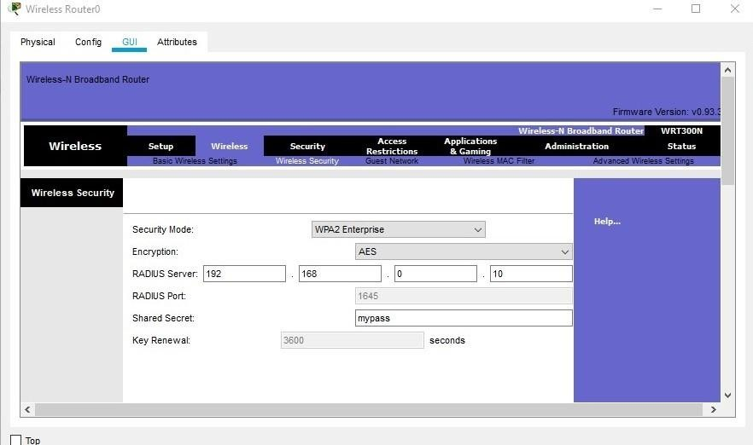

The router is connected to switch and different devices and the server.

#### IoT AND RADIUS SERVER

Remote Authentication Dial-In User Service is a networking protocol that provides centralized authentication, authorization, and accounting management for users who connect and use a network service. The device reads the username and password. The device creates a message called an Access-Request message and sends it to the RADIUS server. The device uses the RADIUS shared secret in the message. This server is used to monitor intelligent things that are recorded on it and to have specific database features .Firstly the IP configurations of the server is set up as shown below -

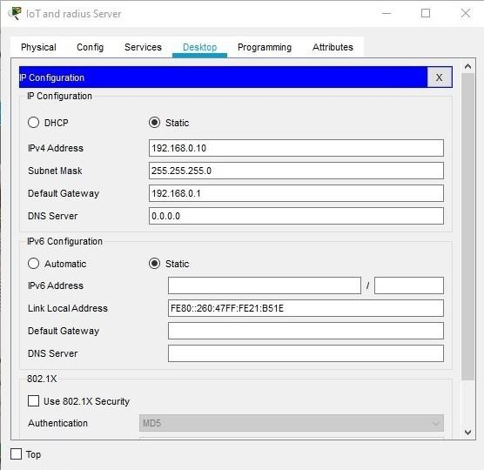

After that we use the AAA framework. AAA is a standard-based framework used to control who is permitted to use network resources (through authentication), what they are authorized to do (through authorization), and capture the actions performed while accessing the network (through accounting). Inside AAA service we set the client name, IP(IP address of therouter) ,secret(which is the same as password set for router) and select theserver type which is radius here.

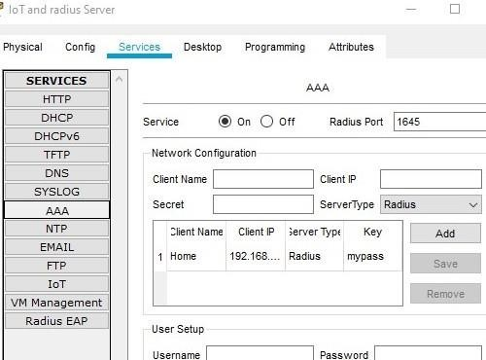

Then the IoT devices to be connected are registered by giving a usernameand password for the associated device as follows-

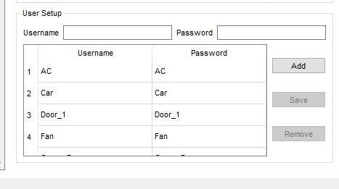

Then we ping the router from the server to check everything is working properly.

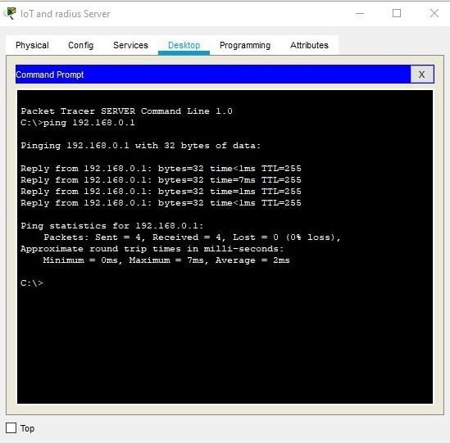

#### REGISTERING TO THE SERVER

We connect a laptop to the router by setting up the IP configurations and then register to the server by providing a username and a password. After registering we can login with same credentials to viewthe devices which have been connected to our network and access them.

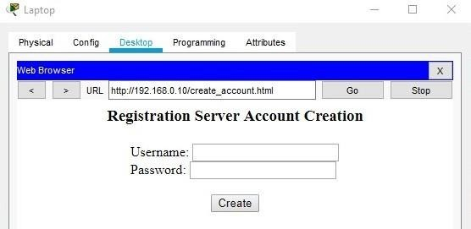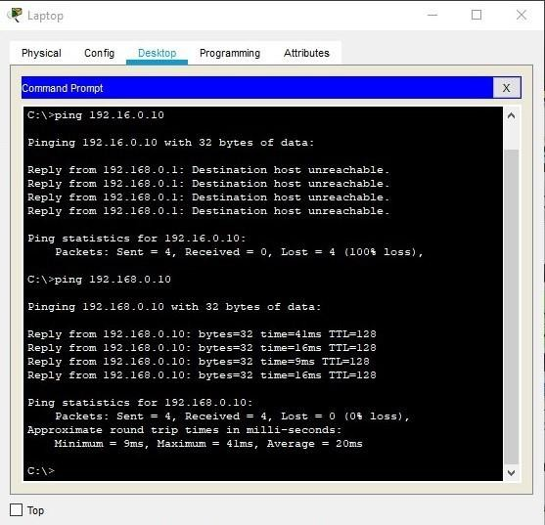

#### SETTING UP DEVICES

For every device the network adapter is set to PT-IOT-NM-1W-AC.After that IoT server is selected as remote server and we provide the IP address of the router along with the password that we registered on the server with. In the wireless configuration part we provide the SSID along with authentication type, encryption type and username, password of the device with which it has been registered on the server.

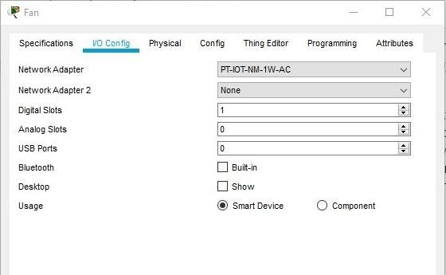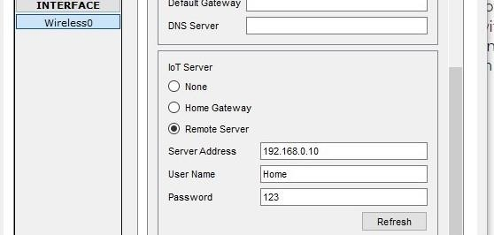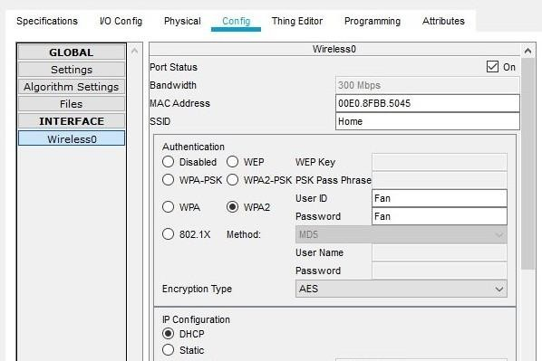

In the same way all the other devices are connected to the server that have been registered and they can now be accessed from the Laptop or Smartphone by logging in with username and password.

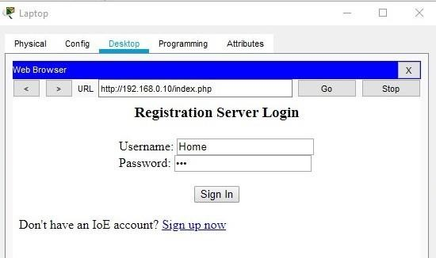

### EXPERIMENT RESULTS AND ANALYSIS

#### RESULTS

After logging in from the web browser we get the following page from wherewe can access all the devices which have been connected.

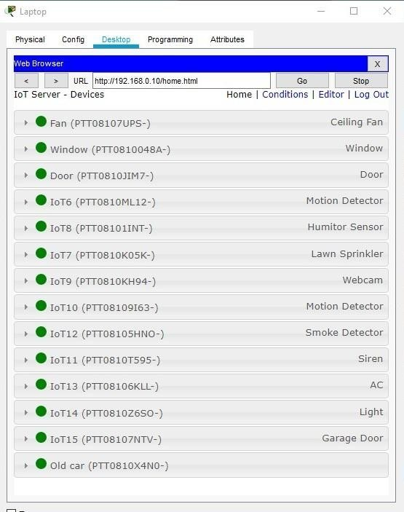

As an example, here we can control fan speed.

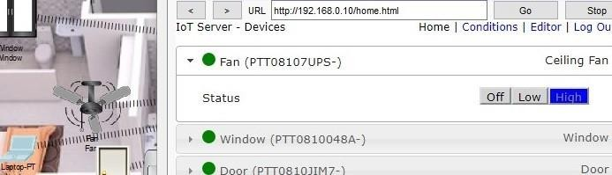

Or we can turn light on or off -

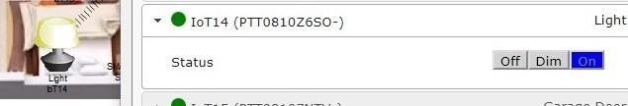

We can also control windows remotely.

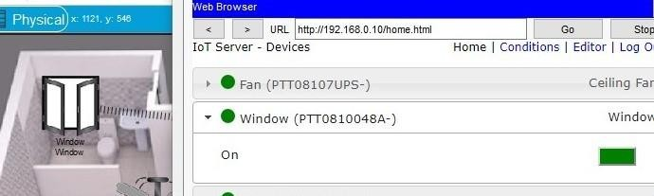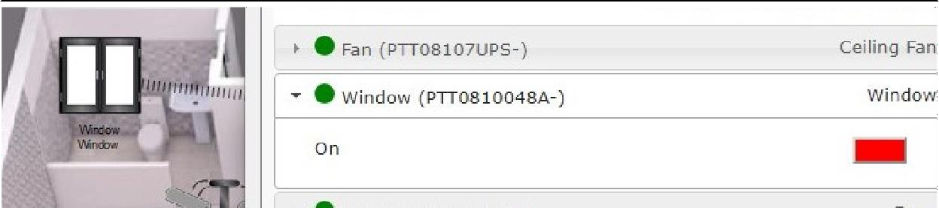

#### CONDITIONS:

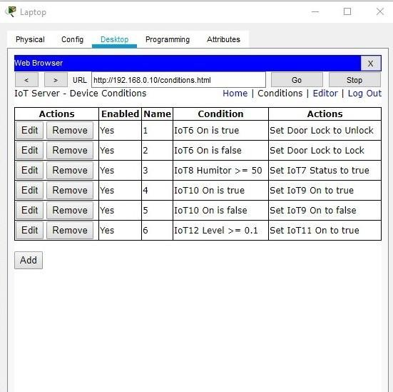

We can also apply conditions to the IoT devices to automatically take some actions if certain conditions are met. The below diagram shows how we can add conditions by selecting the target device and applying conditions on them. For example, in the below picture, there is an if condition. The if block allows us to set conditions we can go to + sign to add conditions. Here, we have selected if IoT6 is true then set Door Lock to Unlock. IoT6 is a motion detector here. As soon as the motion detector senses motion it unlocks the gate automatically.

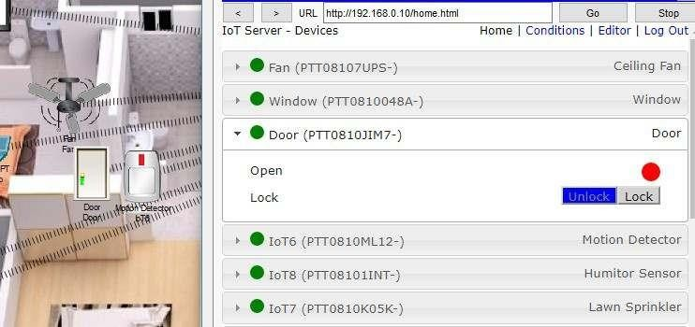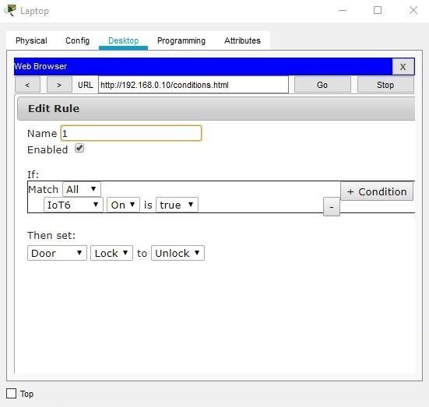

Here as soon as the mouse cursor goes to the motion detector which is a function in the software for motion detector, the door unlocks which we can see.

Similarly many conditions are applied to other devices also be it lawn sprinkler which automatically becomes on by applying some conditions on humiture monitor and siren which starts making sound when smoke detector detects smoke. These devices are connected to each other.

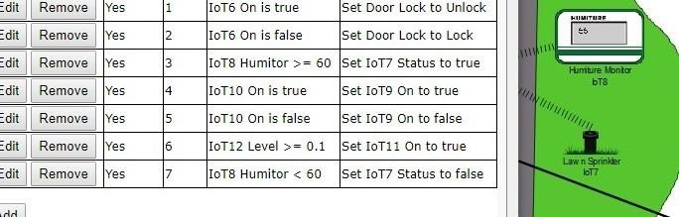

Here the condition is applied such as when the humiture is >= 60 , then thelawn sprinkler becomes on and when it becomes less than 60 it becomes off. Since , humidor meter is showing 56, the sprinkler is off for now.

Similarly we can apply conditions on smoke detector for siren to work

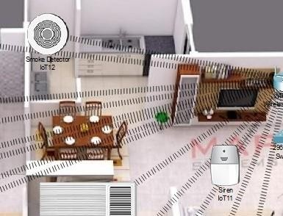

.

**RESULT ANALYSIS**

IoT systems are going to replace present day devices rapidly. The analysis which we can draw is that this is a swift and very easy to use system. Once set up people can easily control their home with their laptop or smartphone. The devices are working properly and devices respond according to the condition set.

**Cost Analysis-**

Cost of smart home systems can be categorized into two parts: installation cost and operating cost. Gesture controlled and Internet controlled systems have comparatively higher installation and operation cost compared to the other systems.

**Speed, Range and Accuracy Analysis**-

Performance of different smart home systems according to speed, range of operation and accuracy are different. The speed and connection strength varies with distance of the devices. This can also affect accuracy.

**Reliability Analysis of Smart Home Systems-**

Based on different issues such as cost, range, speed,accuracy, flexibility, GUI and many other things, it is important to determine whether a smart home system is reliable or not. Reliability of smart home systems is quite important to determine because consumers need to have a clear idea of the product before buying it. If a system fails from time to time then customers will not gain confidence in such a system, so it’s very important to make these devices very accurate.

# Conclusion:

We used the latest cisco packet tracer version to introduce smart home, as this version includes numerous IOE devices. We used the home portal for home automation and record smart devices for monitoring them and microcontroller (MCU-PT) to connect various sensors as well as IOE devices. MCU moreover offers computing environment for different devices and different language of programming.

**FUTURE SCOPE**

Future scope for the home automation systems involves making homes even smarter. Homes can be interfaced with sensors including motion sensors, light sensors and temperature sensors and provide automated toggling of devices based on conditions. More energy can be conserved by ensuring occupation of the house before turning on devices and checking brightness and turning off lights if not necessary. The system can be integrated closely with home security solutions to allow greater control and safety for home owners. The next step would be to extend this system to automate a large scale environment, such as offices and factories. Home Automation offers a global standard for interoperable products. Standardization enables smart homes that can control appliances, lighting, environment, energy management and security as well as the expandability to connect with other networks.

**References:-**

1. <https://smartify.in/knowledgebase/iot-based-home-automation-system/>
2. [http://www.ijstr.org/final-print/feb2020/Implementation-Of-Smart-Home-By-Using-Packet-](http://www.ijstr.org/final-print/feb2020/Implementation-Of-Smart-Home-By-Using-Packet-Tracer.pdf) [Tracer.pdf](http://www.ijstr.org/final-print/feb2020/Implementation-Of-Smart-Home-By-Using-Packet-Tracer.pdf)
3. [https://www.researchgate.net/publication/338422167_Using_Cisco_Packet_Tracer_to_simulate_](https://www.researchgate.net/publication/338422167_Using_Cisco_Packet_Tracer_to_simulate_Smart_Home) [Smart_Home](https://www.researchgate.net/publication/338422167_Using_Cisco_Packet_Tracer_to_simulate_Smart_Home)
4. <https://www.iot-now.com/2020/06/10/98753-iot-home-automation-future-holds/>